**President –** Mr R Inchley

**Trustees –** Mr NClay, Mr J Cusack, Mr R Inchley, Mr R Seldon, Mr P Mackrell

|  |  |  |
| --- | --- | --- |
| **Hon Treasurer**  Mr R Seldon  Blair Drummond  Heath Park Road  Leighton Buzzard  LU7 3BB  07805 805432 | **Chairman**  Mr J Lowe  362 Bideford Green  Linslade  LU7 2TX  07969261972 | **Secretary**  Mr M Furness  30 Mentmore Road  Linslade  LU7 2NZ  07944051136 |

**Annual General Meeting**

**Notice is hereby given to all members of the Club, that an Annual General Meeting will be held at Canal Street Cafe, Leighton Rd, Leighton Buzzard LU71LA, on the Wednesday 26th February 2025 at 8:30pm**

1. **Apologies**

Fiona Towell, Coralie Anderson, Will and Ruth Eastman, James Cusack, Sara Lowe

1. **Appointment of President**

Richard Inchley was welcomed as incoming President.

**3 Chairman’s Report**

**Membership**

|  |  |  |  |
| --- | --- | --- | --- |
| Year | Total | Junior | Senior |
| 2021/22 | 211 | 98 | 113 |
| 2022/23 | 206 | 94*TBC | 112 |
| 2023/24 | 158 | 57 | 101 |
| 2024/25 | 96 | 6 | 90 |

* Membership overall has been impacted by the loss of the junior section in two ways:
  1. Overall reduction in membership
  2. Loss of some members who were parents or helpers with the junior section
* Senior membership remains reasonably stable but has dropped as per point 2 above but also some long-term members moving away from the town, and moreover the just general turnover of members who join the club for a brief period and then move on. The post covid ‘bounce’ we experienced a few years ago has gone.
* We hope to grow the junior section in the next 12-24 months. Senior membership should remain relatively stable. The committee generally feels any large-scale growth would have to come from ‘beginner runners’ which we currently not well resourced to cater for.

**Finances and membership fees**

As we will be reported the club finances are in a very healthy position with a significant surplus. I’ll highlight some ideas in my report, but we’ll also take questions on that post the Treasurers update.

Subject to final conformation with the committee. Membership fees will once again absorb the £1 increase in EA fee, and will likely cut the Senior membership fee by a further £2-4 to give back some of the surplus.

I’d like to thank Pete Mackrell and our Treasurer Roger Seldon for putting the account together.

**Training and coaching courses**

A big thank you to our run leaders / coaches who have helped on our mid-week training or have led a Sunday long run. Attendance at training has been up and down through year. There is a regular core training group on a Thursday but attendance on Tuesdays and Wednesday does fluctuate, although the ‘on tour’ runs appear universally popular. We also added monthly track sessions at Stantonbury Campus in Milton Keynes.

Picking up and theme that I’ll come to in relation to events I would encourage everyone along to training as often as them can make it. It appears that in recent years people’s lives have perhaps taken a busier turn, and with flexible working arrangement as well people are perhaps having in turn more flexibility when they run.

Wednesday nights are social runs and as far as possible are open to all. The nights are planned on the base of a core route with an extension at the end if you want to run further (which may vary on trial routes). There is not a fast or slow group just a choice of distance. People run at their own pace, there is wide variety of paces so looping must always apply and be conducted well to keep the group together. The aim should be a social experience so mix in and speak with others and ensure nobody is left too running alone.

We’re always looking for more people to help on any of our club nights. We have at times struggled this year on some nights due to people’s availability due to injuries etc so we could always use extra help.

We have two people in myself and currently Neil Green undertaking or have undertaken the LiRF course, and I will continue to push this with our run leaders. This is important in terms of ensuring the quality for what we offer, making use of our surplus and thereby investing back into our members and sport.

**Leighton 10 (L10)**

The Leighton 10 was once again a great success this year building strong momentum on the previous year. The planning and organisation went off smoothly, as did the day itself. We had total entries of 242 and 205 people took part on the day (it was 156 for both 2023 and 2022).

Total takings from the event were £4937.00 and profit back to the club was £2,514.07.

Our thanks go to Ian Grimshaw as Race Director and his hard-working Leighton10 Committee for putting on a wonderful event. I’m sure we’ll see the event continue to grow in 2025, and the event is in safe hands.

**Junior section**

In 2025 we had small group of at various time 3-4 juniors regular attend training with me on a Thursday night. In particular, Amy and Nathan and George Perkins have regular attended training also turned up for most of the CCCL showing great commitment to the club.

In 2026 Neil Green will look to complete the LiRF qualification and join me in building up the junior section. This will likely move to Tuesday nights. The club is committed to reestablishing our junior section however small it may be. This is a core part of what we do and set out in our charitable goals. This will be a gradual process. Training will be offered to ages groups 12+ and initially training numbers will be limited with the focus on endurance running.

We will look to engage with parents but if there is anyone within the club who would be interested in helping out it would allow us to offer a more robust training program. When you are reliant on one or two individuals its very easy for training etc to get cancelled so if you have helped before or would like to be part of rebuilding the junior section please let me know.

**Events and Racing**

Each year our Club Captain develops a fantastic calendar of events across our various championship – road, off road, cross country and track and field. Which we once again have in place for 2025.

The year has seen some wonderful team and individual performances, too many to list. From a club perspective the Greensands Ridge Relay was a particular highlight where we took home 3 of the 4 team trophies.

We have seen several vets club records broken, and had people competing in the UK, Europe, Australia and the USA.

At the CCCL we finished in a respectable mid-table position. With some strong performances at some events which shows the clubs full potential. At others we have struggled to get a strong team out or even a full team out for ladies which no doubt impacted on how far up the table we finished.

To pick up a theme we are seeing a noticeable trend over the last two year of diminishing attendance generally across all disciplines. There may well be a variety of reasons for this, and I stress this is not a moan but more a desire to ensure we don’t lose something that makes us the club we are.

Speaking personally and quiet apart from my legs being made of biscuits – I’ve found it very hard to balance work, life and competing much to my own frustration. I’m sure I’m not alone in that, and there may be other reasons such as people not being aware of the events, what the various series awards are for etc. However, all that is speculative so I would say to all members that the committee is open to receiving feedback on the events we choose. We want to know what would encourage you along or what barriers you face. Equally, if this is simply pressures of life, then I don’t create an issue where none exits. So, if we can do something differently then please let us know.

In the next 12 months I encourage our members once again to familiarise themselves with what events are being held and look to participate. We’ve never been a club that says we ‘expect’ people to compete but taking parts at events together, is a big part of what being part of a club is about. It promotes a social and supportive aspect to the club giving you another opportunity to meet up, run, and compete as necessary. None more so that at Cross country events where we really need that team spirit across the club to keep motivating our runners as they tackle the mud and hills. I want to make a special mention to the likes of Carl and Northy for being really troopers in terms of delivering and setting up the gazebo.

**A Golden Year – 2026 – 50th years of LBAC**

In 2026 the club will be 50 years old which is a fantastic milestone. Over the next 12 months the committee will work on plans for how to mark this achievement. We would welcome ideas and involvement from our members so we can make it a special year. Early ideas discuss but nothing finalised have included:

* Bringing back the Round Leighton Buzzard Relay but opening it up to a teams from local clubs
* A commentative technical t-shirt or similar for our members
* Introducing a junior event at the L10 e.g. junior mile or similar

With the clubs healthy financial position, we do hope we can invest some the surplus into plans for 2026.

**Club priorities for the next year**

In no particular order:

* Look to have a new intake of junior members for the first time in 18 months. Building the section in small sustainable way.
* Invest in coaching courses for those that are keen to develop their skills and support the club so we can enhance the quality of what we offer.
* Ensure the Leighton 10 continues to grow and be successful event for the local area.
* Actively encourage and look for ways to boost attendance at training and events.
* Put in place plans for our 50th Birthday year in 2026

I’d like to put on record my thanks to all the committee for their support in the next 12 months, and as we stay together for the next year as well. Thank you to everyone that has helped out with the club behind the scenes and events, we cannot do anything unless we work together. The committee is always here to listen to ideas both for social and running events so don’t shy in coming forward.

Following the Chairman’s report Members discussed ways to spend the Club’s surplus budget, including the upkeep of facilities at Vandyke School, fundraising for a nominated charity, hiring transport to events, and subsidising social events. The Committee undertook to discuss these ideas at the next Committee meeting. The purpose and value of the Club’s charity status was discussed and James Lowe outlined the role and expectations of Run Leaders.

1. **Presentation of accounts for the year ended 31st December 2024**

Roger Seldon presented the Accounts as circulated.

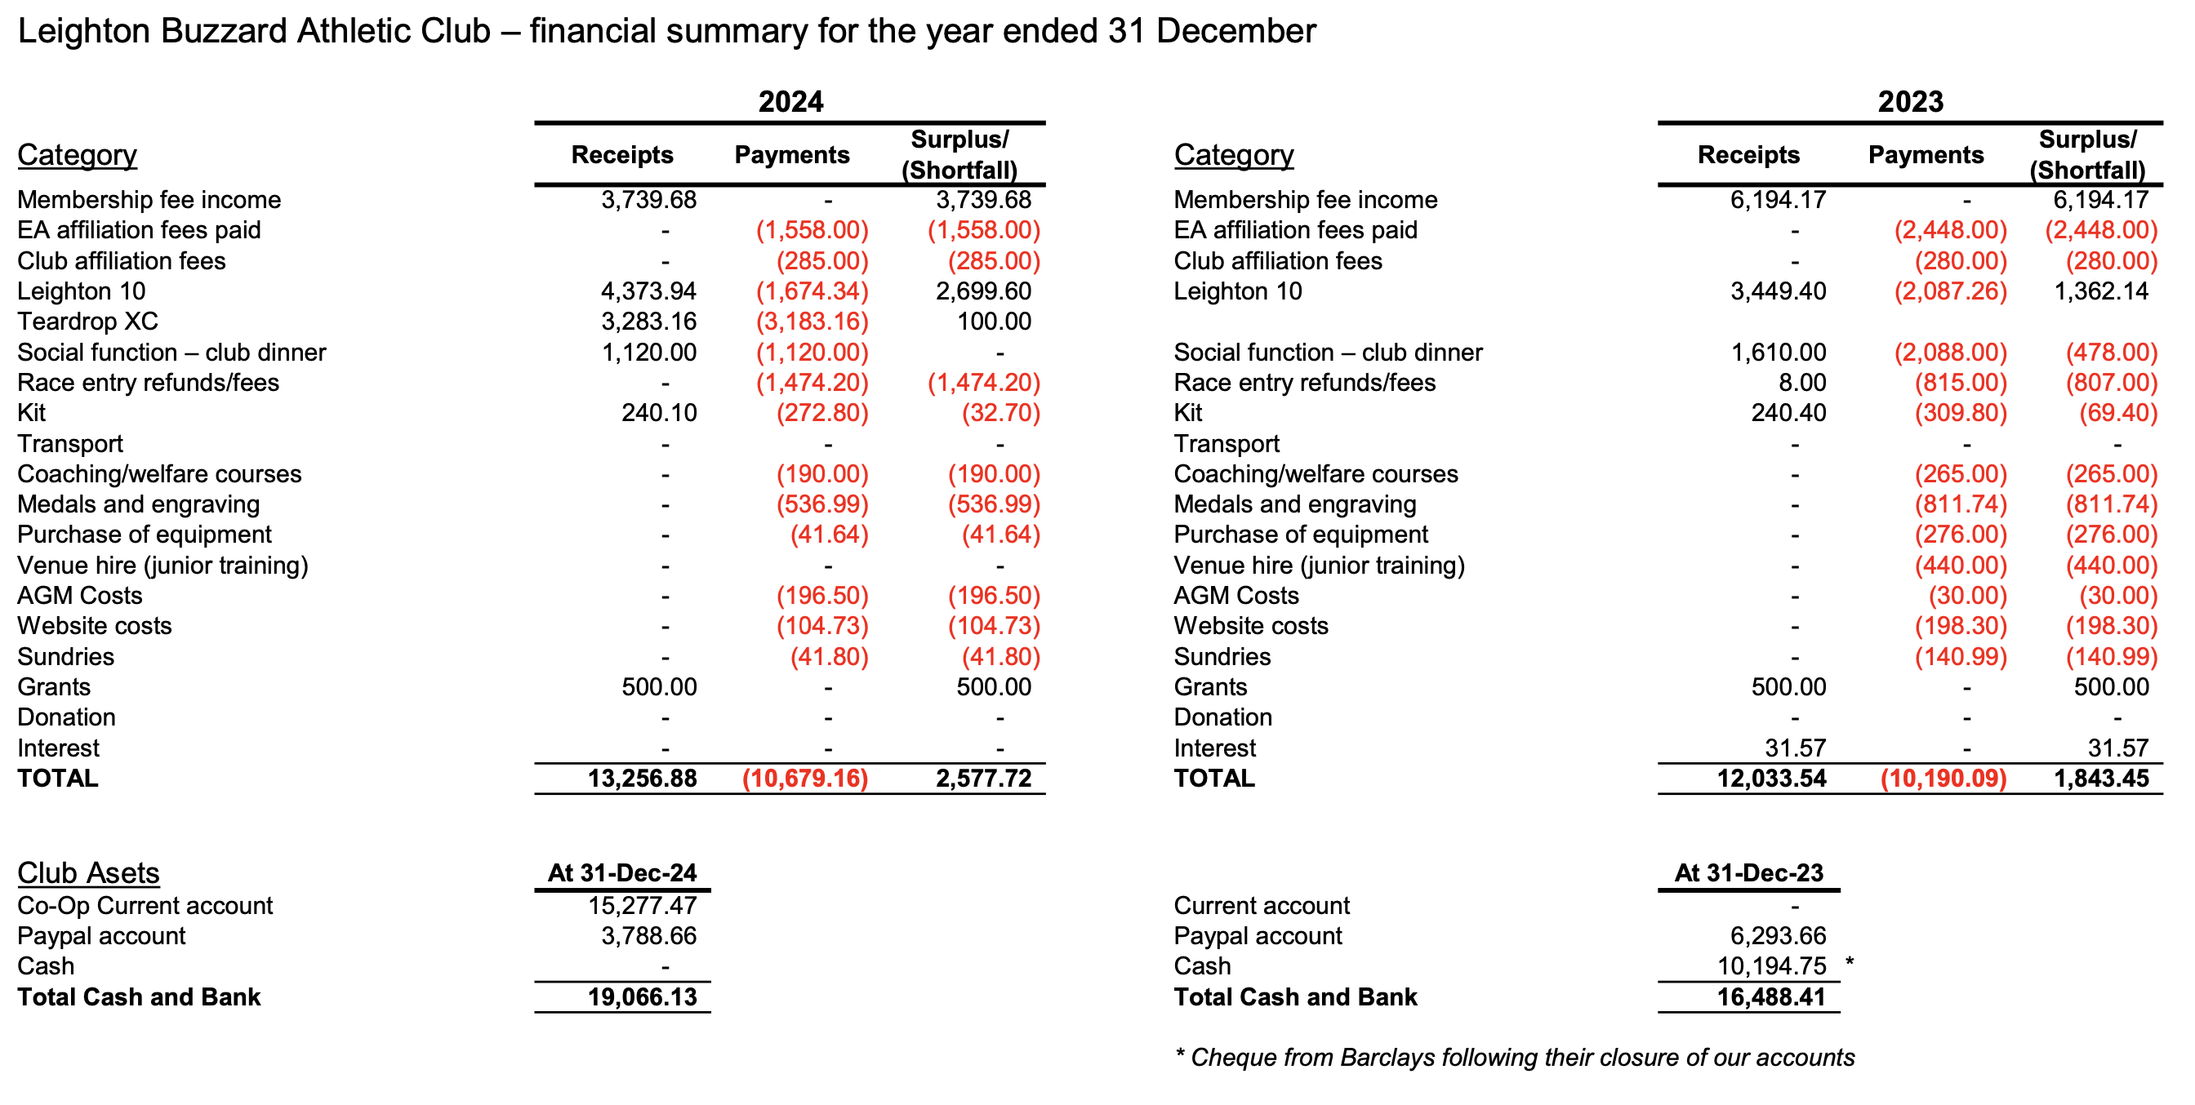

1. **Election of Trustees**

Richard Inchley stepped down as a Trustee.

Richard Inchley was proposed as a Trustee by Andy Inchley ,and seconded by Tim Inchley, and was duly re-elected.

1. **Election of Officers (Please see details overleaf)**

The current Committee was maintained for 2026.

Gary Prysbet has volunteered to become Membership Secretary.

Feedback on the venue for the 2025 Annual Awards Dinner was positive. Volunteers to arrange this year ‘s event are sought.

1. **Any Other Business**

None raised

**Club Officers & Other Volunteers**

**Club President**: Richard Inchley

**Honorary Life Members** Geoff Roe, John Parr, Nick Clay, Rob Bennett and Andy Inchley.

The below table shows the current committee and the proposed committee for 2025-26

|  |  |  |
| --- | --- | --- |
| **Position** | **Committee 2024-25** | **Proposal 2025-26** |
| **Chairperson:** | James Lowe | James Lowe |
| **Secretary:** | Michael Furness | Michael Furness |
| **Treasurer:** | Roger Seldon | Roger Seldon |
| **Captain:** | Sam Dear | Sam Dear |
| **Vice-Captain:** | Valentina Ferrari | Valentina Ferrari |
| **Publicity Officer:** | Sara Lowe | Sara Lowe |
| **Committee Members:** | Jo Dear  Ed Toosey | Jo Dear  Ed Toosey |

**Non-Committee Roles:**

|  |  |
| --- | --- |
| **Membership Secretary:** | Gary Prysbet |
| **Leighton 10 Race Director:** | Ian Grimshaw |
| **Cross Country Fixture lead:** | Richard Inchley |
| **Thursday Training Leaders:** | Michael Furness, Charlie Mead |
| **Run Leaders:** | James Lowe, Ian Grimshaw, Alison Bell, Amy Farnfield, Dan Webb, Liz Peters, Ed Toosey |
| **Annual Dinner Coordinators:** |  |
| **Website Editors:** | Andy Inchley, Sam Dear, Mike Furness |
| **Welfare Officers:** | Jo Dear, Warren Rose |
| **Publicity / newsletters:** | Sara Lowe, Rachel Fawcett, Liz Peters |